**IS 456 IT Database Systems Management**

**Programming Exercise 4**

4/13/2021 Developed by Farzin Bahadori

School of Technology & Computing @ City University of Seattle (CityU)

# Task 1:

Create two tables name contacts and groups (each 5 columns), with contact_id and group_id columns

as a primary and foreign key column.

Create a column named phone numbers and email addresses, and names

Figure 1

# Task 2:

-- Insert values of 5 names, (with email addresses and phone numbers) in to contacts table

-- explicitly name columns

-- then query the table again to make sure the insert was successful

Figure 2

Figure 3

# Task 3:

-- Update existing rows in contacts table, with new values:Johnson for contact_id = 2

Figure 4

# Task 4:

-- Delete rows in groups table where the group_ID is 2

-- Truncate the table

-- Drop the table

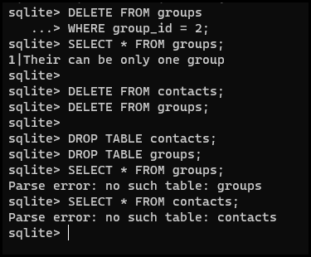

Figure